LEARNING ACTIVITIES
Video „In the beauty centre (Peace solution)”

1.1. Spidergram
Write all the words you know and that you link to the „beauty centre” and „beautician”, as in the example.
beautician
beauty centre

hairdresser

To paint nails

1.2. Words-images connection

1. 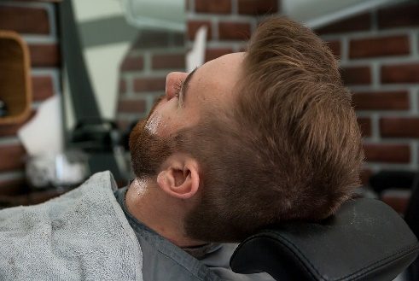 | 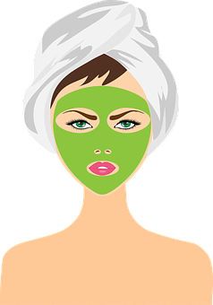  2.
3. 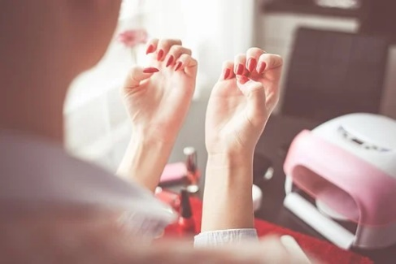 | 4.
5. 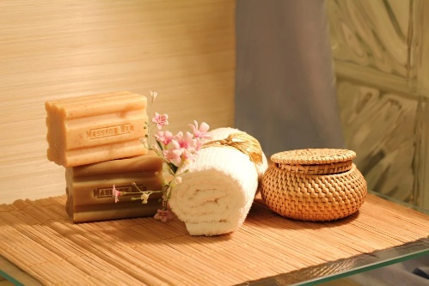 | 6. 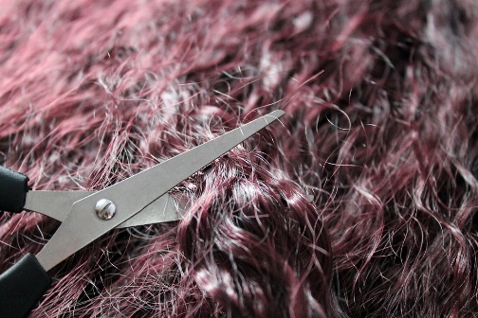
7. | 8.

a) ………… facial treatment | c) ……6…… hair cut | e) ………… massage | g) ………… spa body treatments
b) ………… waxing | d) ………… manicure | f) ……… pedicure | h) ………… barber

1.3. Useful vocabulary
Try to describe how are the following topics like at yor home countryl. You have some useful vocabulary and pharses in English provided in column 2. If you don`t understand them, check their meaning and write it down in dictionary section. Support yourself with your first language if you need.

Topic | Useful vocabulary and pharses in English | Your notes
Hair | to style hair into waves, to reduce thicknes, a wash, cut and dry, a perm, coloured/ dyed, a trim
Spa | wraps and detoxifying body scrubs, massages, certified and tested products, spa body treatments, acupuncture
Nails | nail technician, foot mask, manicure, pedicure, nail polish/gel polish, to paint nails, nail polish remover
Make-up | eylash/brow tinting, cream for mixed skin, eye shadow, lipstick
Other | Waxing, laser hair removal, barber

Dictionary:

to style hair into waves –
to reduce thicknes –
a wash, cut and dry –
a perm -
a coloured/ dyed hair -
a trim –
wraps and detoxifying body scrubs –
massages –
certified and tested products –
spa body treatments –
an acupuncture –
a nail technician –
a foot mask –
a manicure/ pedicure -
a nail polish/gel polish –
to paint nails -
a nail polish remover -
eylash/brow tinting –
a cream for mixed skin –
an eye shadow –
a lipstick –
a barber -
waxing -
laser hair removal -
2.1. True or false
Watch the video and indicate with an X the correct option, as in the example

No | Topic | True | False
1. | The man wants to cut his hair. |  | x
2. | The man wants to have his wife nails done.
3. | It is not allowed to see women`s hair within immigrants culture.
4. | It is not possible to cut hair in private.
5. | The separate room for women is avaliable.
6. | The man does need to accompany his wife while cutting hair.

2.2 Link anwers to questions. Match a beautician`s questions to client`s answers, as in the example.

Beautician`s QUESTIONS
1. Hello. Welcome to the our beauty centre. How can I help?
2. Plese Madam, take a seat. Is it ok?
3. What do you mean? Do you have any special requirements?
4. Can you explain what do you mean by „too many people”?
5. Ok. Let me find the solution. There is a separate room. Would that work for you and your wife?
6. Do you have any other questions? Your wife may follow me to the room.
7. That is ok with me. Let me take you to the room, ok?

Client`s ANSWERS
a. Yes, I do. I need my wife to be with no other clients.
b. Hello, thank you. I would like to have my wife`s hair cut.
c. Ok. We`ll follow you.
d. This is ok. The separate room sound fine.
e. Oh. I need to be present in the room with my wife.
f. No, it`s not. There are too many people.
g. In our culture other people cannot see women`s hair. And here are too many people.

.

Answers
1.  …… b …… | 2. ……………… | 3. ……………… | 4. ……………… | 5. ……………… | 6. ……………… | 7. ………………

2.3. Multiple choice
Watch the video a second time and choose the correct word to complete the sentence, as in the example.
- I want my …… to cut her hair.
  - Cousin
  - Doughter
  - Wife

- Girls, please. This is not …… anymore.
  - Nice
  - Funny
  - Urgent

- Not here. Too many …….
  - Chairs
  - People
  - Noise

- In our culture …… women are not allowed to show their …...
  - Face
  - Nails
  - Hair

- People ……. the street may see.
  - In
  - On
  - At

- There is a room where we do …… and other cosmetic operations.
  - Make-ups
  - Nails
  - Face treatments

- I agree but I ……. to be there, too.
  - Don`t need
  - Need
  - Want

- I haven’t any appointment so the room is …...
  - Open
  - Free
  - Occupied
2.4 Grid
Indicate with an X how the situation is in your country

No | Situation | In my country | Comments
1. | Does women enjoy beauty treatmens in the presence of other people? | Yes/ no
2. | There are many different beauty treatments for women and man. | Yes/ no
3. | It is popular for man to enjoy beauty treatmens. | Yes/ no

2.5. Dialogue
Make pairs. Act a dialogue between beautician and customers based on the following indications and the text of the video. Change roles
Student A  Beautician | Student B  Man
- Welocme the client at beauty centre. | - Say hallo and what is the reason of your visit (cut hair).
- Invite to the chair and beautician. | - Tell about your special requirements (cutting hair in privat).
- Ask what exactly are the special requirements. | - Answer the question and tell about culture aspects.
- Suggest a solution (a separate room). | 4. Agree for the solution.
- Ask for any other requirements. | 5. Point out that you need to be present during the treatment.
- Agree and welcome clients to other room. | 6. Thank for help.

3.1 Vocabulary boxes
Write in the box the words you learned in this unit, linked to the central expression.

Beauty centre
Spa

Facial treatment

